Fujinomiya Bulletin

January ２０２5

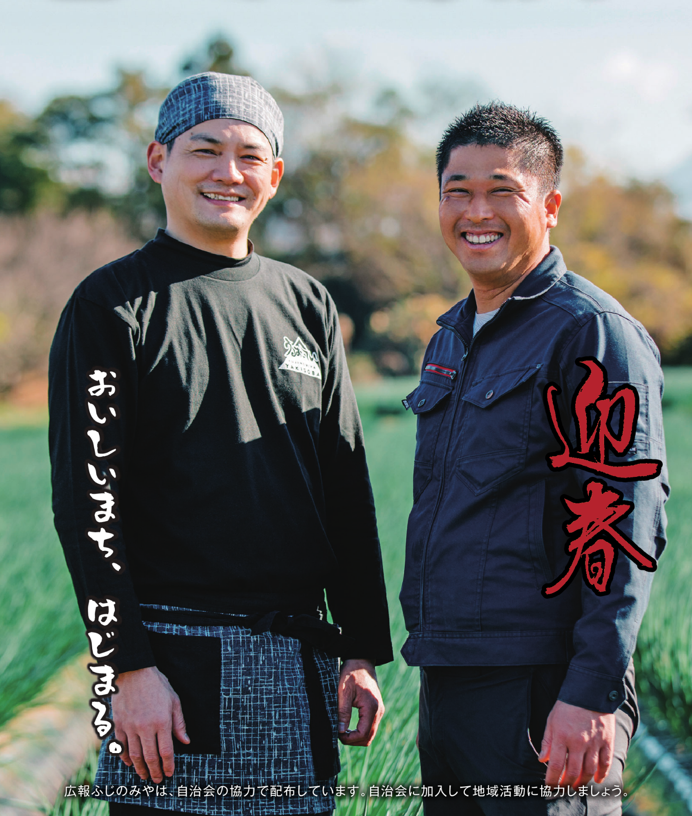

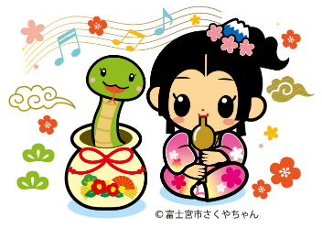

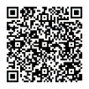

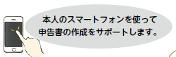
We support to file tax returns using your smartphone.
Information session venue
Tax payment can be made from your designated bank account.

【Date of direct debit】April 23 (Wed)

Process
Please submit the "Request Form for direct debit service (yochokin koza furikae irai-sho ken nofu-sho sofu irai-sho)" to the tax office.

Tax payment by direct debit (automatic transfer)
If your income from public pensions, etc. is less than 4,000,000 yen and your other income is less than 200,000 yen, you do not have to file an income tax return.
*You have to file a residence tax return.
(Please refer to page 4)
Attention
If you wish to receive an income tax refund, you must file a tax return.

Income Tax Return
Please don't forget to file your tax returns by March 17 (Mon).
Tax return venue
Tax returns for those with pension income
※Please use public transportation as much as possible.
※Fuji City Exchange Plaza does not accept any inquiries regarding filing.

■A "numbered ticket" is required to enter the venue.
・"Numbered tickets" can be obtained by LINE in advance.

・"Numbered tickets" will be distributed on the day of the event as well. Depending on the distribution situation, entrance may be refused.

■If you meet one of the following conditions, please file your tax return at Fuji City Exchange Plaza.
・Those who have income from salary, business, agriculture, real estate, interest, dividends, transfers (land, buildings, stocks, etc.), forests, etc.
・Those who file a gift tax return

■Please note that you cannot file your tax return at the tax office from February 17 (Mon) to March 17 (Mon).

Fuji Tax Office
Fuji City Exchange Plaza (fuji-shi koryu plaza)
Tamokuteki-hall, 2nd floor

Period February 17 (Mon) - March 17 (Mon)
9:00-17:00
(Excluding Saturdays, Sundays and national holidays)

JR Fuji Station
Fujihon-cho
Kajima-cho
Fujimi High School
Fuji Post Office
Bank
Bank
Fuji City Exchange Plaza
Fuji City Exchange Plaza (fuji-shi koryu plaza)
Tamokuteki-hall, 2nd floor

Period February 12 (Wed) - 14 (Fri), 9:00-17:00

Eligibility・Those with pension income
・Those who file a mortgage deduction for the first time
Others A "numbered ticket" is required to enter the venue.

Fujinomiya City Hall (fujinomiya shiyakusho)
Tokudai-kaigishitsu, 7th Floor

Period January 27 (Mon) - 31 (Fri), 9:30-16:00 (January31 (Fri): until 15:00)
Eligibility・Those with pension income
・Those who file a mortgage deduction for the first time
Capacity 100 people each day (first-come-first-served basis)


Inquiry
◆National Tax Consultation Dedicated Dial
☎ 0570-00-5901 (Navigation Dial)
◆Fuji Tax Office (Fuji Zeimu-sho)
Tax Return Telephone Consultation Center
☎ 0545-61-2460 (Select # 0)

Inquiry Fuji Tax Office (Fuji Zeimu-sho)
Tax Return Telephone Consultation Center
☎ 0545-61-2460 (Select the number "0")

Tax consultation venue (free)

On-site consultation venue
Fujinomiya City Hall (fujinomiya shiyakusho)
Tokudai-kaigishitsu, 7th Floor

Period February 17 (Mon) – 28 (Fri) 9:30-16:00 Reception until 15:00 (Excluding 12:00-13:00, Saturdays, Sundays and national holidays)

Eligibility・Those with pension income
・Those over 60 years old
・Those with disabilities

Fujinomiya City Hall (fujinomiya shiyakusho)
Meeting Room 710, 7th Floor

Period February 17 (Mon) – 28 (Fri) 9:30-16:00 Reception until 15:00 (Excluding 12:00-13:00, Saturdays, Sundays and national holidays)

Eligibility Those with business income or real estate income※
※Those whose income in 2024 is less than 3,000,000 yen and whose taxable sales in 2023 are less than 30,000,000 yen.

Others Free consultation with a tax accountant will be available.

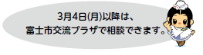
Until March 17 (Mon), you can consult at the Fuji City Exchange Plaza.


You can create tax returns at home
Submission by smartphone or computer
If you use your My Number, you can file tax returns via e-TAX.
For more details, please visit the website "e-Tax".

HP https://www.e-tax.nta.go.jp

You can file your tax return by smartphone, computer, or mail using the National Tax Agency's website "Tax Return Creation (確定申告書等作成コーナー).
The forms are available for download as well.

If you have trouble creating tax returns…
■Chatbot
If you type a question, the answer will be shown automatically.

■Tax Answer
You can review common questions and answers regarding the National Tax.

■Video Channel
You can watch a video on how to operate the Tax Return Preparation Corner.

Inquiry
"e-Tax" Help Desk for creating tax returns
☎0570-01-5901 (Navigation Dial)
☎03-5638-5171

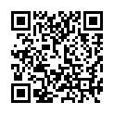
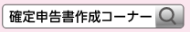

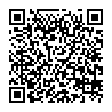
Two types of PINs are required when you use your My Number Card.

■Electronic certificate for signature (6 to 16-digit uppercase letters and numbers)
■Electronic certificate for user certification (4-digit number)

If you do not remember your PIN or your digital certificate has expired, you can reset or renew it at the Citizen Registration Division counter on the 1st floor of City Hall.

Inquiry Citizen Registration Division (Shimin-ka)
☎0544-22-1134

Scan this for tax return creation and the forms.↑
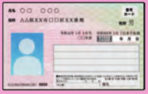

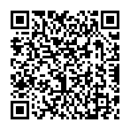

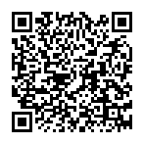

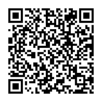

Submission by Mail

Address：Fuji Tax Office
297-1, Motoichiba, Fuji-shi
Zip code 416-8650

Please don't forget to file your tax returns by March 17 (Mon).

Municipal and Prefectural Resident Tax Return
Municipal and Prefectural Resident Tax Return

Inquiry Citizen's Tax Division (Shimin zei-ka)
☎0544-22-1126 FAX 0544-22-1227


Submission by mail
Eligibility
Tax Return forms are available at the counter of the Citizen's Tax Division or at each venue for filing tax returns.
Please check the information you have filled out, enclose all required documents, and send them by mail.

Address: Citizen's Tax Division
Zip code 418-8601
(* Address is not necessary.)
Those who do not file a tax return and who meet one of the followings.
①Those who have income other than public pension income or salary income
②Those who wish to receive income deductions such as medical expense deduction or social insurance premium deduction
③Those who have no income and are enrolled in the National Health Insurance or the Medical Insurance for the elderly
④Those who need a certificate of income

【Attention】Income tax returns are not accepted.
Venues for filing resident tax return

■Branch Office(shucchojo), Ward Community Center(kuminkan), Community Center(kominkan)

■Fujinomiya City Hall

-Check what to bring-

-Income Tax Return

-Municipal and Prefectural
Resident Tax Returns
General Information
If you receive a mortgage deduction

☑ Calculator, Writing utensils
☑ Documents necessary for calculating the amount of income, such as "Tax Withholding Slip (Gensen Choshu-hyo)"
☑ Certificates of various deductions (social insurance premiums, life insurance premiums, earthquake insurance premiums, etc.), medical expense statements, etc.

【Attention】
Medical expense deductions require the attachment of a "Medical Expense Deduction Statement".
You can obtain statement forms at the Citizen's Tax Division or Fuji Tax Office, or download it from the National Tax Agency website.
Please keep medical expense receipts at home for five years, as the tax office may ask you to submit them.
*If you attach the "Notice of Medical Expense" issued by the medical insurer, you may be able to omit filling out the "Medical Expense Deduction Statement".

☑ Something that shows your bank account (in your name)
*If you receive a refund on your tax return.
☑ A copy of your tax return for the previous year
*Only if you have it.
☑ ID of the declarant

【Attention】
You are required to fill in your My Number (personal number) on your tax return and municipal and prefectural resident tax returns.
■One document to confirm
☑ My Number Card *two types of PIN numbers are required, both of which were set at the time of card issuance.

■Two documents to confirm
☑Documents to confirm your personal number (My Number Notification Card or Certificate of Residence with My Number) *After May 25, 2020, the My Number Notification Card cannot be used for those who have a change of address or name.
☑ID document (driver's license, residence card, physical disability certificate, or other document with your photo issued by a public institution) *If it doesn't have your photo, two types of documents are required.

☑ Smart Phone
*Those who wish to receive instruction for creating a tax return.
※You must file a tax return.

☑ A copy of the contract for sale and purchase (contracting work) of house and the certificate of registered matters of house
☑ If you have purchased a site, a copy of the contract for sale of site and the certificate of registered matters for site.
☑ Certificate of the year-end balance of the mortgage loan
☑ If you received a subsidy etc., documents that clarify the amount.
☑ In the case of certified long-term excellent housing, a copy of the certification notice and the residential house certificate or the certified long-term excellent housing construction certificate

【Attention】
Depending on the requirements for receiving the deduction, other documents may be required.
For more details, please visit the National Tax Agency website.

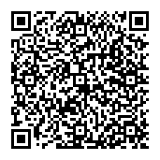

If a proxy files a tax return

※Municipal and prefectural resident tax returns only

☑ Power of attorney
☑ A document to verify the declarant's "My Number (personal number)"
☑ ID of the proxy

Notice of Payment Amount
The amounts of National Health Insurance taxes, Long-Term Care Insurance premiums, and Medical Insurance premiums for the elderly paid during the year 2024 will be mailed to you in late January.

Inquiry Tax & Premium Collection Division (Shuno-ka) ☎0544-22-1128



Information on Pregnancy, Children, Childcare

If your child get sick suddenly
Inquiry Shizuoka Child Emergency Telephone Consultation (Shizuoka kodomo kyukyu denwa sodan)
☎#8000 or 054-247-9910

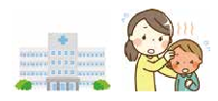
Time Available 24 hours a day

※In case of emergency, do not hesitate to call ☎119

Counseling for children
Inquiry Family and Child Counseling Section, Children's Future Division
(Kodomo mirai-ka, katei jido sodan-kakari) ☎0544-22-1230

Time Weekdays 8:30～17:15
Inquiry Child Guidance Center (Jido sodan jo)
For consultation only: ☎0120-189-783

Time Available 24 hours a day

Counseling on abuse
Inquiry Child Guidance Center (Jido sodan jo)
For abuse only: ☎189

Time Available 24 hours a day

Counseling on bullying, truancy, attitude toward life, and employment
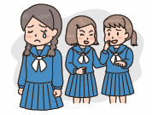
Inquiry Youth Counseling Center (Seishonen sodan center)
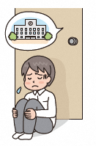
Elementary and Junior high school students: ☎0544-22-0064
Junior high school students - 39 years old: ☎0544-22-1252
E-mail Counseling : e-sodan@city.fujinomiya.lg.jp

Time Weekdays 9:00～17:00 (Until 19:30 on the 2nd and 4th Wednesday of each month)

 | Male | Female | Total | Household
Population | 63,162 | 63,855 | 127,017 | 59,313
Month to month basis | (+13) | (-56) | (-43) | (+57)
The number of population and households (As of December 1st, 2024)

Information on Seniors, Health, Medical Care, Nursing Care, and Disabilities

Notice | To all National Health Insurance members,
A "Notice of Medical Expenses", which lists the medical expenses you received in November and December 2024, will be sent to you in late February.
If you wish to file a medical expense deduction before the notice arrives, please use your receipts.

Inquiry Insurance and Pension Division (Hoken Nenkin-ka) ☎0544-22-1138

Information on Events, Applications, Notices, National Insurance, Pensions, Subsidies, Aids, Businesses

Recruitment | Accepting applications for public housing (municipal housing) tenants
Applications for public housing tenants will be accepted for those who wish to move in April 2025.

Application Submit the application form (available on the city's official website) to the counter between January 14 (Tue) to 20 (Mon).
Others The drawing will be held on January 27 (Mon). Please be sure to attend (or send a representative).
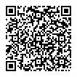
Inquiry Building and Housing Division (Kenchiku Jutaku-ka), 5th floor of City Hall ☎0544-22-1163
HP トップページ＞市民の皆さんへ＞住まい・ペット・動物＞住まい＞市営住宅入居者募集案内

Recruitment | Japanese Language Course
When Every Tuesday from January 7 to March 18
Time 19:00-20:30
Where Exchange Center "Ekimae Koryu Center KIRARA"
Number of students recruited 10 students (non-Japanese)
Fee 3,000 yen
Application Please call the "Ekimae Koryu Center KIRARA".
Contact number Fujinomiya Association for International Relations “FAIR” ☎0544-22-8111

Notice | National Pension System when you turn 20 years old
All persons between 20 and 59 years old who have a domicile in Japan are obligated to enroll in the National Pension System.

Type of Pension

When you turn 20 years old, the Japan Pension Service will mail the "Notice of National Pension System Enrollment" and the "Notice of Basic Pension Number" to you.
(excluding Category 2 insured persons)

Category 1 insured persons
Please pay the National Pension Insurance premiums with the payment slip enclosed in the "Notice of National Pension System Enrollment. (You can also apply for payment by direct debit or credit card.)
If you do not pay, the amount of pension you receive may be reduced after retirement or you may not be able to receive it.
Pensions not only guarantee income after retirement, but also are provided in the case of disability due to illness or injury.
If you have difficulties in paying the premiums, please use the "Special Student Payment System", the "Exemption from Premium Payment System", or the "Postponement of Premium Payment System".

Inquiry
Pension Member Dial ☎ 0570-003-004
Fuji Pension Office (Fuji nenkin jimusho) ☎ 0545-61-1900

Notice | Replacement of Water Meter
Water meters that have been installed over 7 years will be replaced free of charge.
A designated water supply equipment installation contractor commissioned by the city will visit in February.
Do not place any objects around the meter box.

Target area Awakura, Awakura minami-cho, Sugita, Nukudo, Maimaigi-cho, Hoshiyama, Mannohara shinden, Misonodaira
Inquiry Water Works Division (Suido gyomu-ka) ☎0544-22-1158

Schedule from January 1st to February 10th

■First–aid Medical Treatment Center (Kyukyu Iryo Center)
☎0544-24-9999 / Fax: 0544-24-9995 / Address: 12-1 Miyahara, Fujinomiya, Zip Code 418-0005
Medical treatment subject | Day | Time
Internal medicine (Naika), Pediatrics (Shonika), Surgery (Geka) | Weekdays | 19:00-8:00 on the next day
 | Saturdays | 14:00-8:00 on the next day
 | Sundays, Public holidays,  Year–end and New year holidays | 8:00-8:00 on the next day
Dentistry (Shika) | Sundays, Public holidays,  Year–end and New year holidays | 9:00-17:00  *Reception: until 16:30
*If your condition is severe, dial 119 for ambulance. Make sure to bring your health insurance card with you.

■Emergency Ophthalmological Clinics (Ganka) Open: 9:00-17:00
*Please make sure to contact the clinics beforehand as they may change.
Date | Clinics name/ Address | Tel
January 1 | Unno Ganka Iin/ Matsuoka Fuji city | 0545-30-6260
January 2 | Saito Ganka Iin/ Nishikoizumi-cho | 0544-28-5615
January 3 | Toda Ganka Iin/ Miyahara | 0544-21-9666
January 5 | Nakanishi Ganka Clinic/ Nakano Fuji city | 0545-36-1800
January 12 | Sugiura Ganka/ Kawanarishinmachi Fuji city | 0545-65-8500
January 13 | Hanazaki Ganka Iin/ Aoba-cho Fuji city | 0545-66-0100
January 19 | Fujinomiya Goto Ganka/ Nishimachi | 0544-21-3100
January 26 | Kato Iin Yoshiwara-bunin/ Chuo-cho Fuji city | 0545-57-3000
February 2 | Nagano Iin/ Yunoki Fuji city | 0545-60-7100
February 9 | Nakagawa Ganka/ Oiwa | 0544-29-6000

■Emergency Obstetrics and Gynecology Clinics (Sanfujinka) Open: 9:00-24:00
*Please make sure to contact the clinics beforehand as they may change.
Date | Clinics name/ Address | Tel
January 5 | Fujinomiya City General Hospital/ Nishiki-cho | 0544-27-3151
January 12 | Tenjin Sanfujinka Iin/ Wakanomiya-cho | 0544-24-1322
January 19 | Otabe Sanfujinka Iin/ Hibarigaoka | 0544-23-1182
January 26 | Bando Ladies Clinic/ Sugita | 0544-28-5800
February 2 | Fujinomiya City General Hospital/ Nishiki-cho | 0544-27-3151
February 9 | Tenjin Sanfujinka Iin/ Wakanomiya-cho | 0544-24-1322
■Blood Donation
Date | Clinics name/ Address | Time
January 4 | AEON Mall Fujinomiya/ Asama-cho | 9:30–16:00*
January 11 | AEON Mall Fujinomiya/ Asama-cho | 9:30–16:00*
January 14 | City Hall / Yumizawa-cho | 9:00–16:00*
January 18 | AEON Mall Fujinomiya/ Asama-cho | 9:30–16:00*
January 26 | AEON Mall Fujinomiya/ Asama-cho | 9:30–16:00*
* Not implemented from 12:00-13:15

Inquiry Welfare Planning Division (Fukushi Kikaku-ka) ☎ 0544-22-1457

■Due Dates for tax or other payments
Date | Taxes to be payed
January 6 | Property tax / City planning tax (3rd term)
January 6 | Natinal Health Insurance Tax (6th term)
January 6 | Medical Insurance Premium for the elderly (5th term)
January 6 | Long Term Care Insurance Premium (6th term)
January 6 | Child care fee (for December usage)
January 6 | Public housing fee / Parking fee (for December usage)
January 28 | Water charges and Sewerage charges (for December usage)
January 31 | Medical Insurance Premium for the elderly (6th term)
January 31 | Contribution for public sewerage system (4th term)
January 31 | Child care fee (for January usage)
January 31 | Public housing fee / Parking fee (for January usage)
February 3 | Municipal and prefectural resident tax (4th term)
February 3 | Natinal Health Insurance Tax (7th term)
February 3 | Long Term Care Insurance Premium (7th term)

■Counseling and Consultation *Not implemented on public holidays.
〈Place: Citizen counselling room, 1st floor, City Hall〉
Consultation | Date & Time
- General counseling (Ippan sodan)  - Counseling for non-Japanese residents (Gaikokujin sodan) | Monday-Friday 8:30-17:00  (*Reception: until 16:30)
- Counseling on consumer affairs (Shohi seikatsu sodan) | Monday-Friday 9:00-16:00
④ Attorney (Bengoshi sodan)  *Appointment is required (by 12:00 the day before the consulting day, seats are limited to the first 7 people) | January 8, 15, 22, 29  (13:30- until the end of the consultation)
⑤ Judicial scrivener (Shihosyoshi sodan)  *Appointment is required | January 10 13:00-16:00
- Licensed tax accountant (Zeirishi zeimu sodan)  *Appointment is required | January 7, 21 13:00-15:00
- Administrative scrivener (Gyosei syoshi sodan) | Not implemented for this month.
- General administrative counseling (Gyosei sodan) | January 9 10:00-15:00
- Consultation on the human rights (Jinken sodan) | January 21 13:00-16:00
- Consultation on side jobs (Naisyoku assen) | Mondays and Thursdays 9:00-16:00
- Patent attorney (Benrishi sodan) *Appointment is required. | January 24 15:00-17:00
- Business start-up consultation (Sogyo sodan)  *Appointment is required. | January 28 10:00-15:00
①,③-⑨ Community Service Division (Shimin Seikatsu-ka)
② Citizen Exchange Division (Shimin Koryu-ka)
⑩-⑫ Commerce and Industry Division (Syoko Shinko-ka)

☎ 0544-22-1196
☎ 0544-22-1246
☎ 0544-22-1295

Inquiry

〈Place: Meeting Room 510, 5th Floor, City Hall〉
Consultation | Date & Time
Real estate transaction agent (Takuchi tatemono torihikishi sodan) | January 14 13:00-15:00

Inquiry Construction and Housing Division (Kenchiku Jyutaku-ka) ☎ 0544-22-1163

〈Place: Meeting Room 113, 1st Floor, City Hall〉
Consultation | Date & Time
Pension consultation (Nenkin sodan) *Appointment is required. | January 23 10:00-15:00

Inquiry Fuji Pension Office in Fuji city（Fuji Nenkin Jimusho） ☎ 0545-61-1900


富士宮市
FUJINOMIYA CITY

■City Hall Open Days on Holidays: We open on the first Sunday of each month.
January 12 (Sun) *Tax & Premium Collection Division only
February 2 (Sun)
8:30-17:00

Division & Phone number | Services
Citizen Registration Division  (Shimin-ka)  ☎ 0544-22-1134〈Certification and My Number Card〉  ☎ 0544-22-1135〈Family Register and Address〉 | - Submission for Family Register (koseki) (birth, marriage, death, etc.)  - Submission of change of residence (moving into the city, moving out of the city, moving within the city, etc.)  - Application for seal (inkan) registration and abolition  - Issuance of various certificates (certificate of residence(jyuminhyo), Family Register(koseki tohon, koseki syohon), certificate of seal(inkan) registration)  - Receiving passports  - Procedures for applying for My Number Card  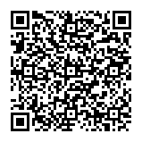  The services we handle are different from normal days. For details, please call or visit the city's official website.
Insurance and Pension Division  (Hoken Nenkin-ka)  ☎ 0544-22-1138 | - Qualification and disqualification for National Health Insurance
Child Future Division  (Kodomo Mirai-ka)  ☎ 0544-22-1146 | - Application for Child Allowance and Child Medical Expense Beneficiary Certificate
Tax & Premium Collection Division  (Shuno-ka)  ☎ 0544-22-1129〈Payment〉  ☎ 0544-22-1128〈Certification〉 | - Payment of city taxes, etc. and Consultation on payment  - Issuance of tax certificates  ※Appointment is required in advance for tax consultation.  ※Tax exemption certificates, etc. that require a declaration cannot be issued

■After-hours service: Every Wednesday until 19:00pm
*No services if a public holiday falls on a Wednesday.
Division & Phone number | Services
Citizen Registration Division  (Shimin-ka)  ☎ 0544-22-1134 | - Application for seal (inkan) registration and abolition  - Issuance of various certificates (certificate of residence(jyuminhyo), family register(koseki tohon, koseki syohon), certificate of seal(inkan) registration)  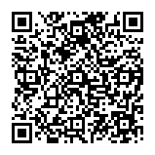  The services we handle are different from normal days. For details, please call or visit the city's official website.
Tax & Premium Collection Division  (Shuno-ka)  ☎ 0544-22-1129 | - Payment of city taxes, etc. and Consultation on payment  - Issuance of tax certificates  ※Appointment is required in advance for tax consultation.  ※Tax exemption certificates, etc. that require a declaration cannot be issued

